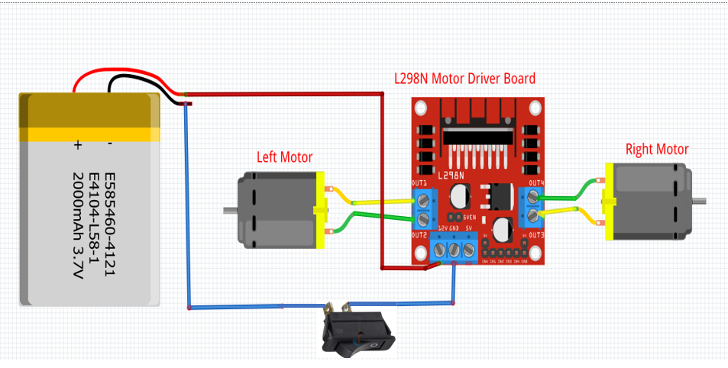

**RPI GND PIN**

**L298N MOTOR DRIVER –**

**WIRING OF POWER SUPPLY**

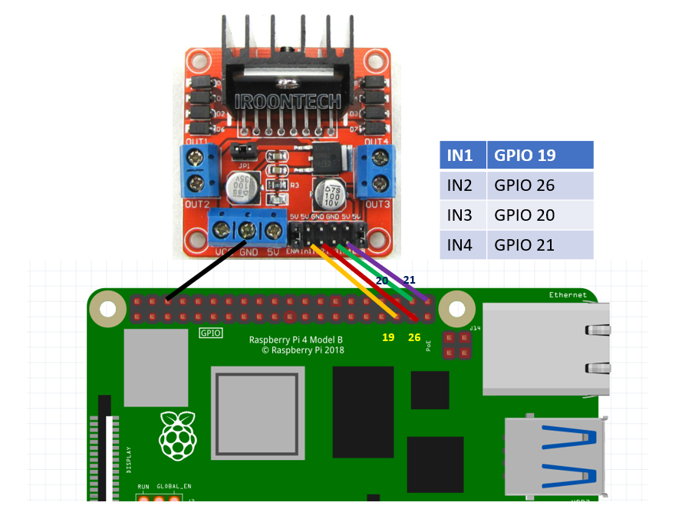

**GND**

**L298N MOTOR DRIVER –**

**CONNECTION TO RASPBERRY PI**